***SOFTWARE PROJECT FINAL REPORT***

LiLou DeRivera, Keaton Dinger, Hitesh Kukreja, Nathan Sikon –2823726

Online Casino/Blackjack Group 11

04/20/2025

Table of Contents

List of Figures

-Use case

-Model-View-Controller

-User interface design

-Static design

-Dynamic design

List of Tables

-Risk Analysis

-Traceability

-Test Case

-Traceability of test cases to use cases

**1. Introduction**

1.1. Purpose and Scope

- Purpose: The purpose of the project is to replicate a digital version of blackjack for purely recreational purposes where no real money is involved. This simulated version of blackjack allows users to play against a ‘computer’ dealer.

- Scope: As this is a replicated game of blackjack, all traditional rules apply, including the dealing of cards, hitting, standing, checking for busts and wins. The software will include a simple UI that displays the user their options. The user will be playing against a digital dealer to earn more “chips”, a non-real currency for the game.

1.2. Product Overview (including capabilities, scenarios for using the product, etc.)

- The software replicates an online blackjack game, only the user plays against the dealer and no real currency is used. The user begins with a pre-determined number of chips. Once the game starts, the user places their bet, and the user and dealer are dealt their cards. After, the user can perform actions such as ‘hit’ and ‘stand’. After making their choice, the dealer gets their cards. Then, the game decides who won and lost.

This target for this software is for those that want a casual blackjack experience without the pressure of gambling with real-world money. It can also teach players the general rules of blackjack for if they would like to play the game in casinos or with friends.

1.3. Structure of the Document

- The document is structured in 7 parts:

1) Introduction – introduces the project with its purpose, scope, and product overview

2) Project Management Plan – Outline pre-requisites for the project. It includes organization of the project, the project’s development lifecycle, the identification of any risks associated with the software, and hardware + software resource requirements.

3) Requirement Specifications – This section identifies the stakeholders, use cases (accompanied by a use-case model) and rationale for them, and non-functional requirements

4) Architecture – Identifies the architectural styles, architectural model and rationale for said model, and technology, software, and hardware used.

5) Design – Includes the design of the interface, components design + rationale, database design, and traceability

6) Test Management – Include a list of testcases, traceability of testcases, techniques used for testcase generation, test results and assessments, and a report of defects.

7) Conclusions – Outcomes of the project, what was learned, and what directions can be taken for future development

1.4. Terms, Acronyms, and Abbreviations

- ‘bust’, when a user’s combined numerical score is greater than 21, they lose that game.

- ‘blackjack’, when a user’s initial two cards combine numerically to equal 21, they get a blackjack. When this happens, their bet is rewarded 3/2.

- ‘hit’, a blackjack term where the user wishes to receive an additional card. User can ‘hit’ as many times as they wish, until they bust.

- ‘stay’, a blackjack term where a user forfeits receiving additional cards.

**2. Project Management Plan**

2.1. Project Organization

- Our group is made up of four people (LiLou, Keaton, Hitesh, and Nathan). We all have shared roles on our team, meaning that everyone helps each other out in equal parts in regard to developing, testing, and UI design.

2.2. Lifecycle Model Used

- The lifecycle model that we decided to use as a group was the “Waterfall Model”. Because the model is good for project with well-defined, unchanging requirements, it was a great choice for software where we replicate an already-existing game of blackjack.

2.3. Risk Analysis

- Risk Table

|  |  |  |  |
| --- | --- | --- | --- |
| RISK NAME | PROBABILITY (Low, Medium, High) | IMPACT (Low, Medium, High) | RM3 POINTER |
| Browser compatibility issues | Medium | High | Related to UI testing and cross-browser support |
| Performance issues | Medium | High | Linked to optimization techniques in rendering |
| Project Delays | High | Medium | Related to time management and milestone tracking |
| Scope Creep | Medium | High | Connected to project scope management |

2.4. Hardware and Software Resource Requirements

- The software is web-based and designed for computer use, not smart phones. For this reason, a computer (Windows, Mac, or Linux) is needed that has access to a web browser.

2.5. Deliverables and schedule

Phase 1: Planning

. Define project scope, objectives, and constraints

. Identify core functionalities

. Risk assessment

. Development project timeline and milestones

Phase 2: Modeling

. Design architecture

. Create UI wireframes and layout

. Define data structures

. Plan state management

Phase 3: Construction

1. Core game mechanics of Blackjack

2. User interface and interactivity

3. Game logic and refinement

Phase 4: testing and debugging

. Test functionality

. Works across different browsers

. Fix identified problems

Phase 5: Deployment and Feedback

. Test the game out on a web server and gather feedback

**3. Requirement Specifications**

3.1. Stakeholders for the system

- Project Team: Everyone involved in the development of the software has helped to build and maintain it. Each team member’s grade is dependent on the quality and what the team delivers with the software

- End Users: The users that play the game are a big stakeholder as their experience determines the success of the project

- Instructor/grader: Very important in the grading process, as they expect certain deliverables and functionality relating to our specific project.

3.2. Use cases

3.2.1. Graphic use case model

3.2.2. Textual Description for each use case

- Register/Login: Player can create a new account or login to their existing account that holds their chip information

- Place Bet: Player can initiate a game by placing their bet

i) Play Hand: The player is then able to play the game given the available options:

A) Hit

B) Stay

- Mange Profile: The user is able manipulate aspects about their profile, like chip count, is also able to delete their account

- Game Settings: The user is able to manipulate the shoe size of the game, and can adjust music sound the game provides

3.3. Rationale for your use case model

- The model shows a simple graphic of all the actions that the user has in the software. The reason why an arrow leads from the user to place bet, to play hand, and then the four call options is to show the linear progression of how each function is accessed. For example, you cannot play a hand without first placing a bet.

3.4. Non-functional requirements

- Some non-functional requirements include:

i) Blackjack Simulation Logic (game functionality)

ii) Game outcomes must be provably fair (outcomes must be achieved logically in the bounds of blackjack logic)

iii) Performance (Response time should be quick without noticeable delay)

**4. Architecture**

4.1. Architectural style(s) used

- Model-View-Controller

4.2. Architectural model (includes components and their interactions)

- 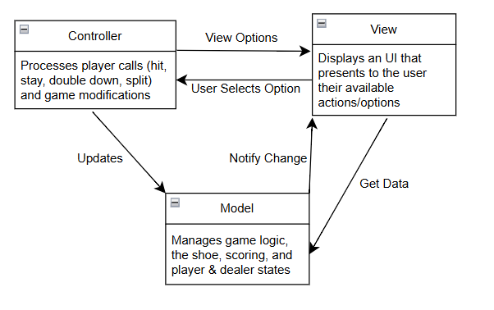

4.3. Technology, software, and hardware used

- No external/physical technology was used. What was used to create the software was CSS to format the webpage, and JavaScript for the interactivity and dynamic behavior of the web page, and then HTML to define the structure and content of the webpage.

4.4. Rationale for your architectural style and model

- Model-View-Controller was used because the software requires three logical parts of handling game logic, displaying UI, and having player actions update the model, and so on. In the instance of blackjack, it is especially helpful to have the ‘Model’ manage game logic and the different states, ‘View’ to handle UI and other visualizations, and ‘Controller’ to process player inputs to update the model accordingly. Additionally, the separation of the three parts makes testing and maintaining the software much easier and simplistic.

**5. Design**

5.1. User Interface design

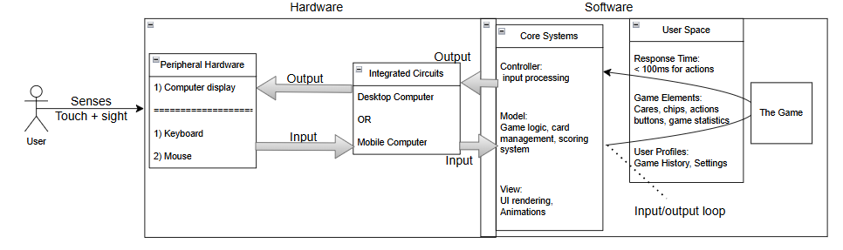

5.2. Components design (static and dynamic models of each component)

-Static

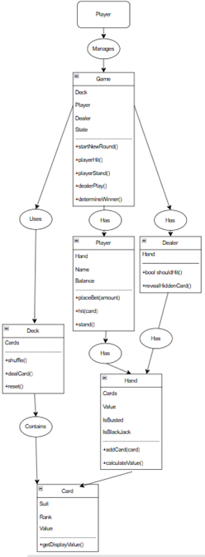

-Dynamic

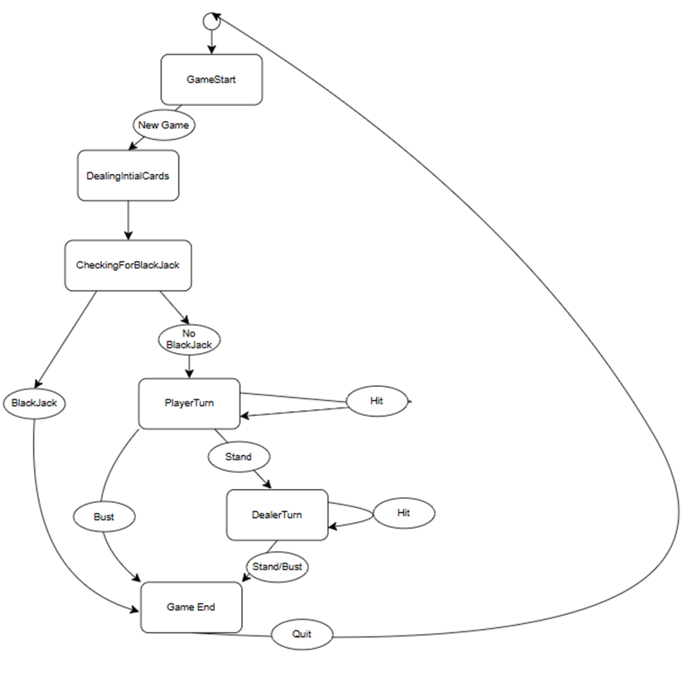

5.3. Database design

- In the database, the software takes login information, username and password, from the user. The user is able to create a new account by using a unique username and a password to go with it. If the user attempts to create an account with an already existing username or incorrectly enters their password, that account cannot be created or accessed. The accounts hold player information, being chip count.

5.4. Rationale for your detailed design models

- The static model shows a linear path of the software’s structure during a game of blackjack. The model depicts attributes, the entities that house them, and all of their relationships as they interact.

The dynamic model illustrates accurately shows the execution loop of the software. It shows the beginning and end from when the user first starts a new game, the choices that they’re able to make, and if they enter the win/lose state.

5.5. Traceability from requirements to detailed design models

|  |  |  |  |  |  |
| --- | --- | --- | --- | --- | --- |
| Requirement ID | Component | Design  Component | Status | Requirement  Type | Test Case ID |
| REQ-1 | User Authentication | User Management 3.2.1 | Finished | Functional | TC-101: Test login scenarios |
| REQ-2 | Betting System | Betting Engine 3.2.1 | Finished | Functional | TC-201: Verify bet validation |
| REQ-3 | Blackjack  Logic | Game Logic 3.2.1 | Finished | Non-Functional | TC-301: Verify by playtesting |
| REQ-4 | Chip Management | Virtual Wallet  3.2.2 | Finished | Functional | TC-401: Verify Currency Updates |
| REQ-5 | Game outcomes provably fair | Game Logic  2.2 | Finished | Non-Functional | TC-501:  Verify game RNG |

**6. Test Management**

6.1. A complete list of system test cases

|  |  |  |  |  |
| --- | --- | --- | --- | --- |
| Test Case | Description | Input | Expected Output | Pass/Fail |
| TC01 | Place valid bet | $50 | Game starts with 50$ dedcuted | Functional |
| TC02 | Place bet more than bank | 2000$ | Alert shown, no deduction | Functional |
| TC03 | Invalid bet amount | 0$ | Alert shown, no deduction | Functional |
| TC04 | Deal cards to player and dealer | Start game | 2 cards for player, dealer starts with 1 visible | Functional |
| TC05 | Player hits and stays | Hit once, then stay | Dealer plays, results displayed | Functional |
| TC06 | Player hits and busts | Hit repeatedly | Player score > 21, can’t hit again | Functional |
| TC07 | Player wins | 20 vs dealer 18 | Win message, bank updated | Functional |
| TC08 | Player loses | 16 vs dealer 20 | Loss message, bank updated | Functional |
| TC09 | Tie | 18 vs 18 | Tie message, refund bet | Functional |
| TC10 | Music plays | Turns on and stays in | Music playing in game | Functional |

6.2. Traceability of test cases to use cases

|  |  |
| --- | --- |
| Use Case | Related Test Cases |
| UC01-Place Bet | TC01, TC02, TC03 |
| UC02- Start Game | TC04 |
| UC03- Player Actions (Hit/Stay) | TC05, TC06 |
| UC04- Evaluate Results | TC07, TC08, TC09 |
| UC07- Settings (Music) | TC10 |

6.3. Techniques used for test case generation

* Equivalence Partitioning: Tested valid vs invalid bet amounts, edge cases (eg. 0$, max value)
* Boundary Value Analysis: Bet at $10 (min), $1000 (max), bank limits
* State Transition Testing: Checked state changes between game start, hit, stay, and new round
* Exploratory Testing: Hitting
* Use Case Based Testing: Ensured each user interaction was covered with related test cases

6.4. Test results and assessments (how good are your test cases? How good is your software?)

Total Test Cases: 14

Passed: 11

Failed: 3

Assessment:

Strong – All primary cases and UI elements tested.

Test Effectiveness: High – Issues such as money logic, edge behaviors, and invalid input handling were accounted for

Software Quality:

Stability: High – Most core features perform reliably

Usability: User friendly with intuive controls and feedback besides music which is not too tedious

Maintainability: Good – code structure is modular and testable

6.5. Defects reports

In some cases, the cards load slower than when the outline appears. This could be a defect due to the load times or just processing power of one's computer.

**7. Conclusions**

7.1. Outcomes of the project (are all goals achieved?)

All outcomes have been achieved. Shoe size was reinterpreted as a settings bar that could manipulate some items on the website. This includes things like music.

7.2. Lessons learned

Developing a website that works smoothly and works well is difficult. Starting with an earlier design plan and sticking with it is a great tool to have when developing an application though. Having all code mapped out and each step you took so you can find any error was useful after halfway into development. We kept track of each step we needed to take and succeeded in making a working product. Bit more than what we could chew with adding features and double down is being extremely buggy so we removed it for now.

7.3. Future development

Expanding our product to have a greater purpose. Make more casino games and rework the money system where you have chips instead of hard cash. When developing the game too we will create our original music and allow ourselves to organically grow into a staple fake gambling site.

**References**

<https://bicyclecards.com/how-to-play/blackjack/>

<https://www.gamblingsites.org/casino/blackjack/>

<https://www.w3schools.com/howto/howto_make_a_website.asp>

[https://github.com/](https://github.com/topics/blackjack)

<https://pixabay.com/music/search/casino/>